How to Ask an Open-Ended Question

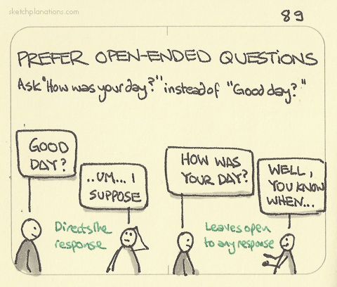

There are two ways of asking questions: close-ended and open-ended.

Close-ended questions
- Can be answered with either a single word or a short phrase such as “yes” or “no.”
- Are easy to answer and provide no details or analysis.
- Do not encourage in-depth or long-range thinking.

Open-ended questions
- Are likely to receive an in-depth, detailed answer.
- Ask the respondent to think and reflect on what he or she has read.
- Encourage critical thinking that leads the respondent to think beyond the reading assignment.
- Usually begin with “how,” “why,” or “what.”

Examples:
Close-Ended | Open-Ended
Do you get along well with your supervisor? | How do you view your relationship with your supervisor?
Who will you vote for in this election? | What do you think about the two candidates in this election?
Did you like that story we read for this week? | What did you think of the story we read for this week?
Did the protagonist act unwisely in the story? | Why did the protagonist make the choices she did?
Did you understand Macbeth? | What were the consequences of Macbeth’s actions?

General Open-Ended Question Template
- What do you think about ?
- In what way does the story/poem ?
- How would you interpret the character’s ______?
- How did the ending ?
- What was the problem ?
- Why did the story/poem ?
- Why did the character react ?
- What did it mean when ?
- How does the symbolism ?
- What kind of conflict ?

