SOC313 PowerPoint Instructions

- Please visit How to Make a PowerPoint Presentation at the AU Writing Center to view directions on creating a scholarly PowerPoint. The directions include information such as font size, number of bullet points for each slide, adding images, adding Speaker’s Notes as well as how to add and format citations and references.
- Each slide must include detailed Speaker Notes. The word count guideline for the Speaker Notes is approximately 100 to 200 words depending on the number of components covered on the slide.
- Must be presented using Microsoft PowerPoint slide presentation software. Follow the directions on the How to Make a PowerPoint Presentation page that allow you to download Microsoft PowerPoint for free if you do not have Microsoft PowerPoint.
- Must utilize academic voice. See the Academic Voice resource for additional guidance.
  - Each slide must have detailed speaker notes written in paragraph format with APA formatted citations where applicable. You can review the tutorial using this link: adding speaker notes to your presentation. You can also click on the following links to view the accessibility statement, and the privacy policy.
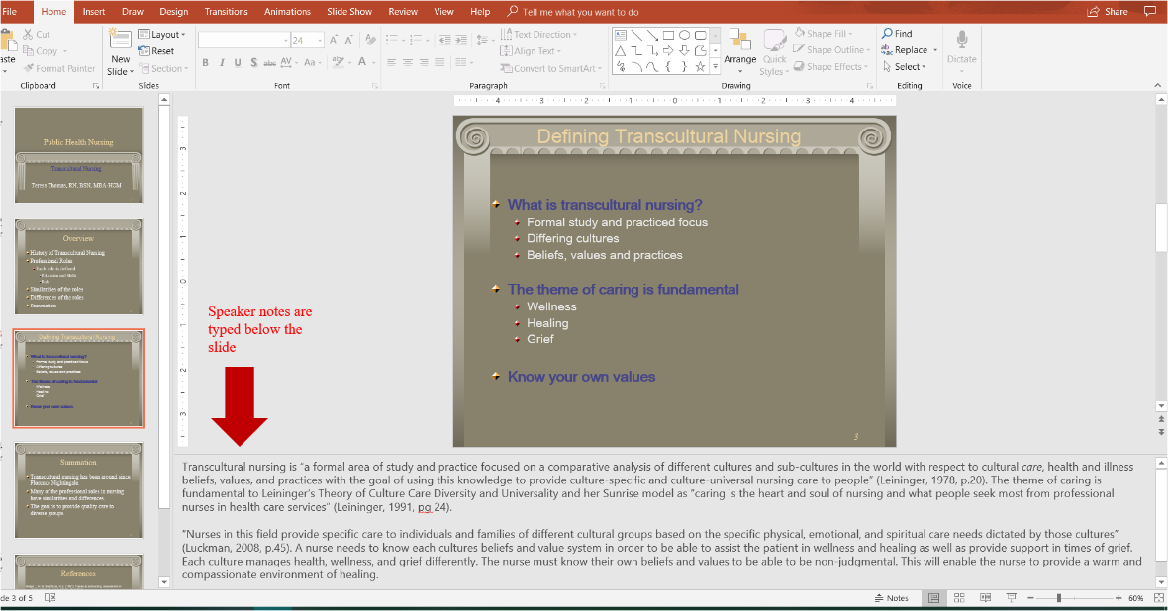
    - What are speaker notes? Speaker notes are located under each slide. This area must contain the narrative portion of your presentation. The speaker notes are to be typed in paragraph format. The notes explain in detail each of the bulleted points that you have placed on the slide. Whereas the slides will have short bulleted points (statements), the speaker notes will be more detailed. They are essentially what the presenter would say during the presentation to explain each of the bulleted points on the slide. Therefore, it is important that the speaker notes are concise and detailed when explaining the bullet points. The speaker notes must also contain citations for the referenced material used in the narrative.
- It is recommended that PowerPoint slides contain four to five bullet points and should not contain more than 5 – 7 words each. Do not type paragraphs or long sentences on the slide. The information that explains each bullet point is conveyed via speaker note. Present the issues with critical thought.
- The Presentation must be visually engaging. For assistance with designing the visuals for your presentation, view the video Don McMillan: Life after death by PowerPoint (click on the following links to view the accessibility statement or the privacy policy) or the PowerPoint Best Practices tool.
- Slides should follow the organization as shown in the directions, with a clear and logical progression of ideas.

