Create a Table

CREATE A TABLE IN WORD
- Click on INSERT
- Click on Table Icon
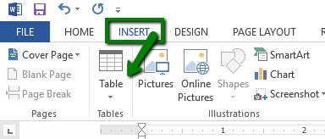
- Set the dimensions of your table and begin filling out your table with the information required for the assignment.

CREATE A TABLE IN CANVAS
- Click on reply underneath the discussion prompt
- Click on the table icon
- Set the dimensions of your table
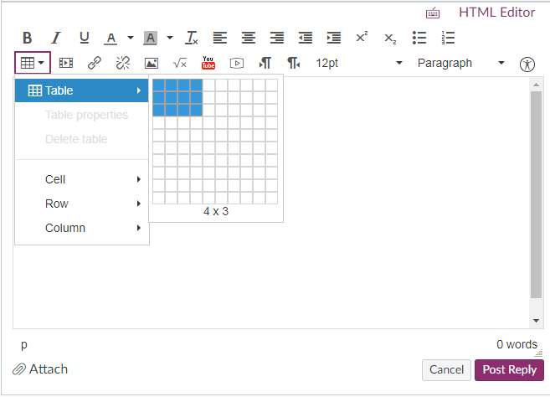
- Begin filling out your table with the information required for the assignment.
