A Priori Model Evaluation-ARCS Commercial Mortgage Company  by [Article Author]  INF220 Week1 Hot Topics  Enterprise Systems News Report  Student’s Name:  Instructor:  Edition1 Vol1 |  | A Priori Model Evaluation  - ARCS Commercial Mortgage Company  - Issue Date
INF220 WeeK1 Information Systems – the big picture |  | In This Issue

Describe one dimension of the A Priori Model
Enter your text here…

A Priori Model Enterprise System Evaluation
The author applies the A Priori Model enterprise system evaluation measures to the Information Technology organization identified by the Ashford University INF220 Week1 Guest Speaker, Dr. Stephanie Young Gonzaga, previous CIO – ARCS Commercial Mortgage Company.
This is the first edition of the INF220 Subject Matter Expert SME Video series to bring real-world learning into the course room.

Page #

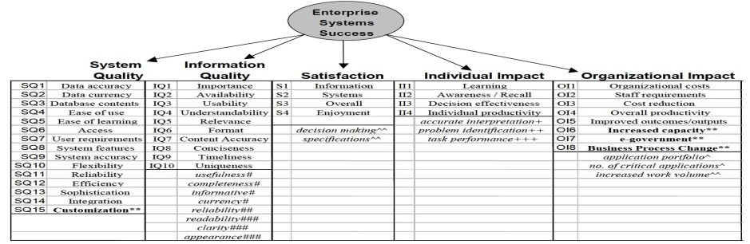
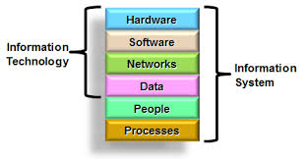
  - Identify how Dr. Gonzaga’s IT organization provided enterprise systems that addressed your selected A Priori Model dimension of success (system quality, information quality, satisfaction, individual impact, or organizational impact).

Enter your text here…

The A Priori Enterprise Systems Success Measurement Model

References

Enter your reference List here….

A Priori Model Evaluation
ARCS Commercial Mortgage Company

