Tricider Help Guide:

This week’s discussion will take place in an online app called “Tricider.” There, you will be able to post your ideas for plan components, and also share pros and cons of different proposals during the week. Finally, you will be able to vote on what you think should be in the plan.

- Start by clicking the link to the specific Tricider page provided by your instructor in the Week 4 discussion.

- Post two ideas. Due by Day 3. Locate the “Add idea” button to add your initial posts. Remember that you are responsible for posting two ideas prior to Day 3 of the week.

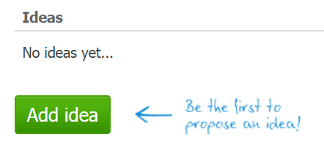
Figure 1: Image of "Add idea” button

Tip: When posting ideas, be sure to make them different enough from the ones already there that two won’t overlap. Then one might take votes from the other one, and both could lose out.

- Share at least six pros and/or cons for your classmates’ ideas. Due by Day 5. Each pro or con should be written out as a single clear, complete sentence.
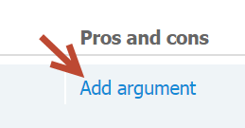
Figure 2: Image of "Add argument" link
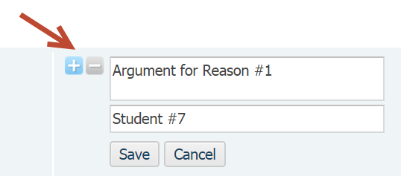
Figure 3: Image of adding a rationale

- Vote for three (3) different ideas. Due by Day 7 You may vote any time after midnight on Thursday. You may not vote twice for the same idea, and you may only vote three times total.
Figure 4: Image of voting icon

- Share the rationale behind your voting choices. Due by Day 7. After casting your vote, open up Discussion Two inside the Ashford University classroom.

